Assignment 2 - Twitter Service

short line

**Team :**

[Sanjana Rajesh Kothari](mailto:sanjanarajesh.kothari@sjsu.edu)

[Siddhant Sancheti](mailto:siddhant.sancheti@sjsu.edu)

[Ravi Teja Reddy Dodda](mailto:ravitejareddy.dodda@sjsu.edu)

[Naga Bathula](mailto:nagasrinivasarao.bathula@sjsu.edu)

[Harika Satti](mailto:harika.satti@sjsu.edu)

18 th September, 2022

# 

# Assignment

1. Develop custom twitter service api’s that implements any Twitter API to programmatically create, retrieve and delete a Tweet in the Twitter Sandbox environment.
2. Develop a simple Web UI that implements your service and demonstrates the functions
3. Develop unit test cases

Deliverables : github url for code , Documentation (with screenshots)

# Approach

As a group, the team worked on understanding the requirements first. Then we decided to research on the following areas which are key to start development.

1. Twitter developer portal, twitter sandbox, twitter API 1.0 vs 2.0, Authentication scheme
2. Technology choices for Frontend and API development

After completing initial assessments here are the technology choices made based on ease of development , skill set of the team and future project goals

**Front End :** HTML, bootstrap, Jquery , css

**Backend development:** Python and Django Framework

Twitter 2.0 API using Developer Portal Apps

**Tests :** Django Test Framework

Home Page for Twitter Test Service

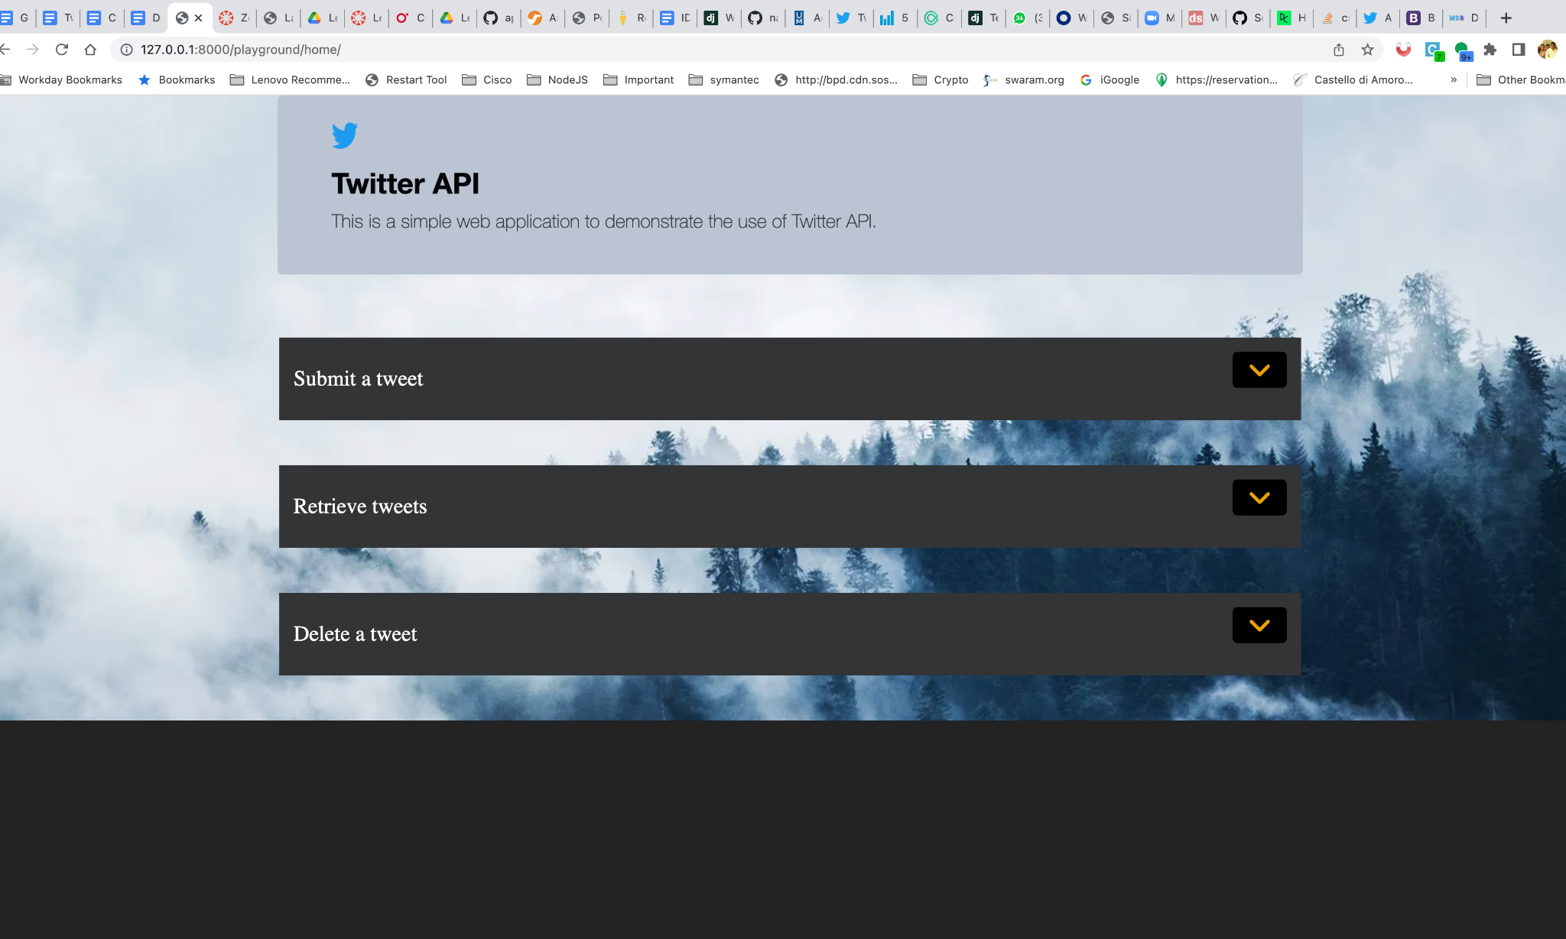

This page has four different sections

1. Submit a tweet
2. Delete a tweet
3. Retrieve tweets based on userhandle
4. Results from the twitter api are captured and returned in a modal dialog

*Note ; All the backend calls are made inline using the Jquery Ajax module . The results are updated automatically shown in a modal dialog without forwarding to a new page.*

Submit a tweet

Once the tweet text is entered and submit the form, the text is posted and success response is returned in the modal dialog

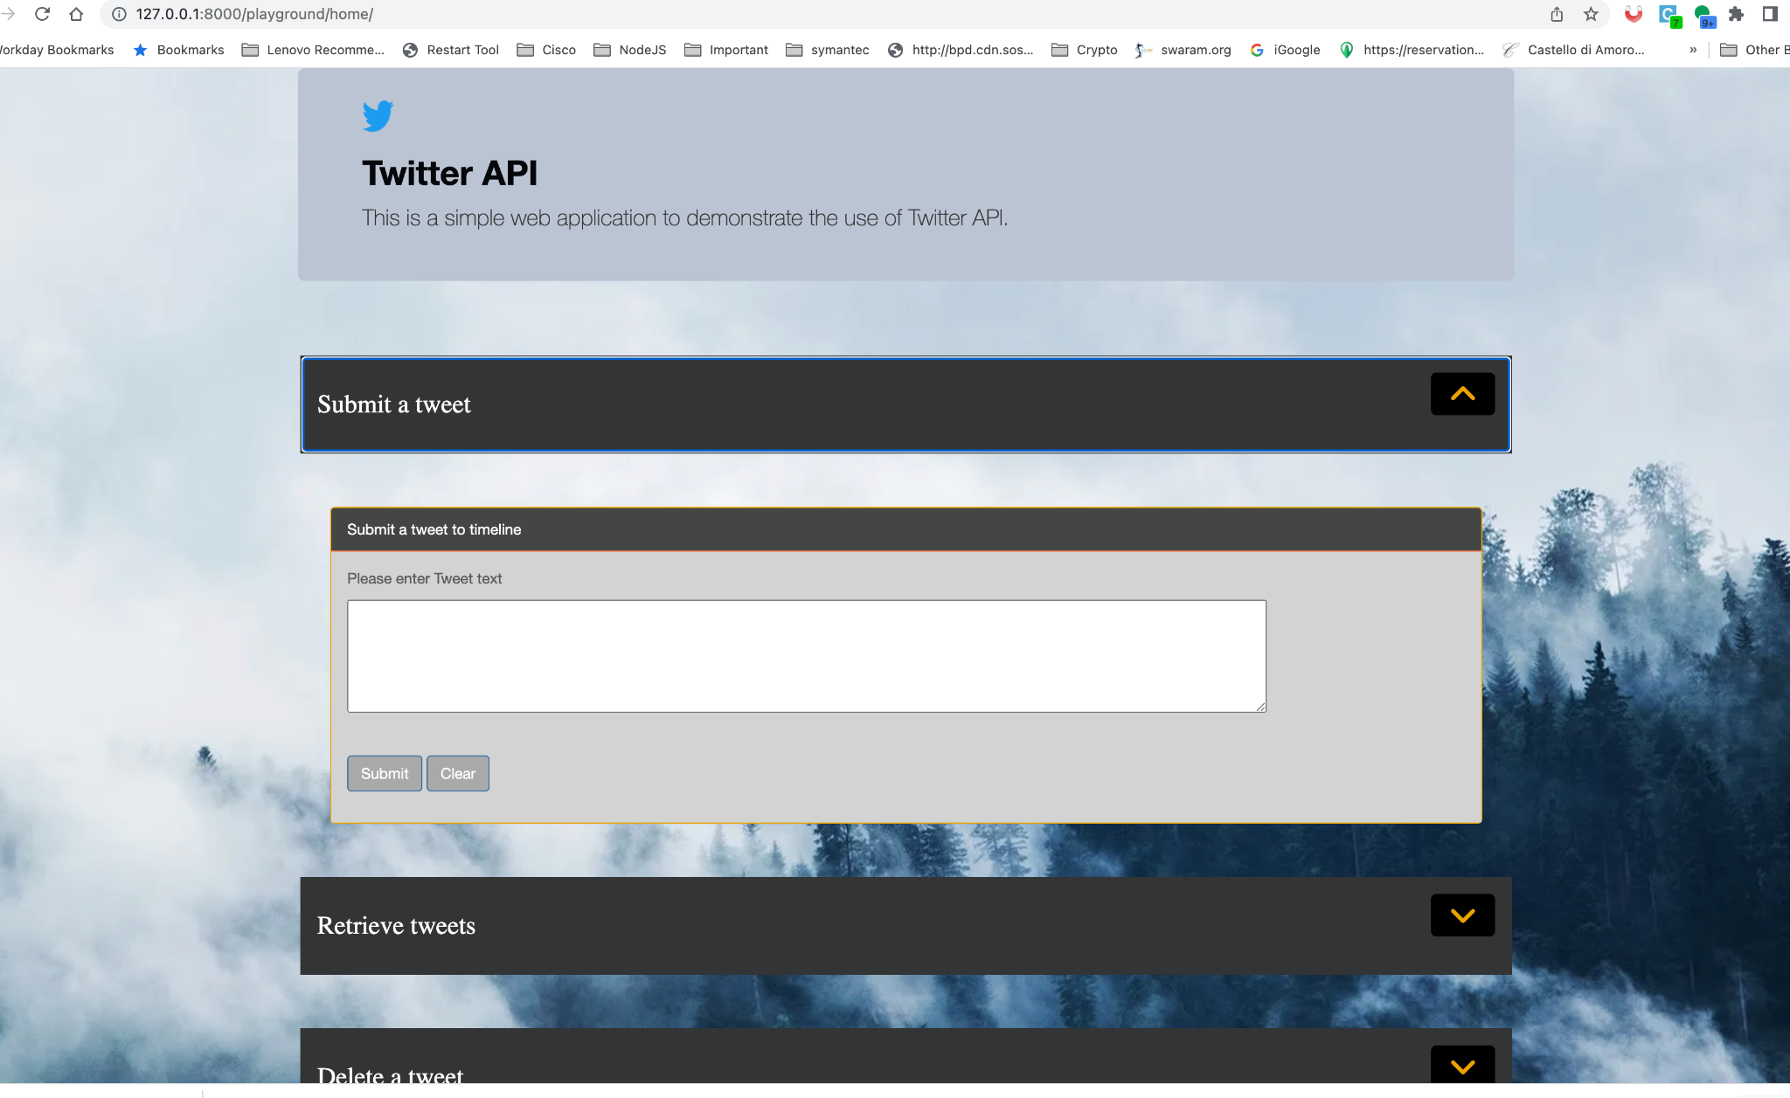

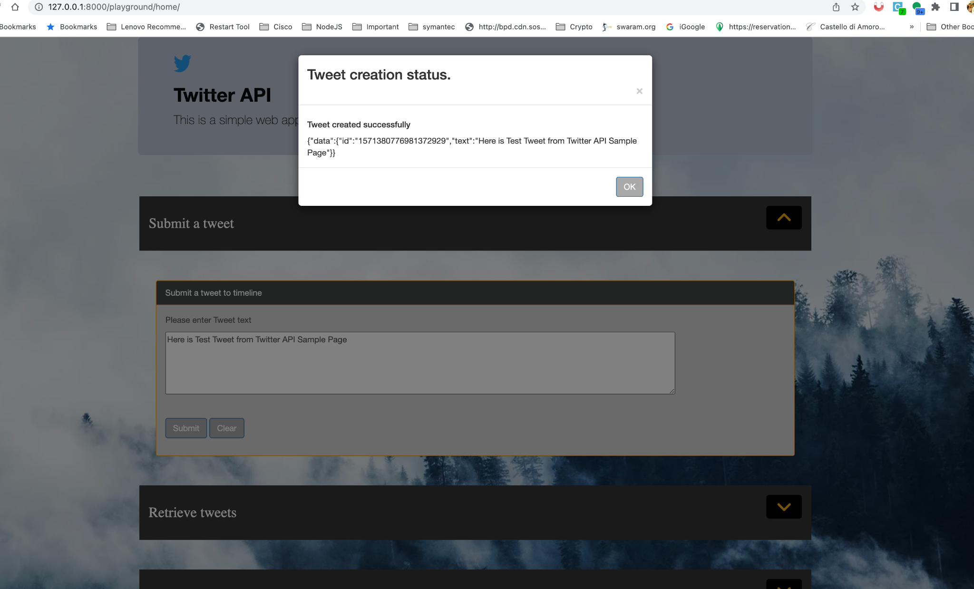

Delete a tweet You need to provide a tweet id in the form and click delete and a success message is returned in the modal dialog

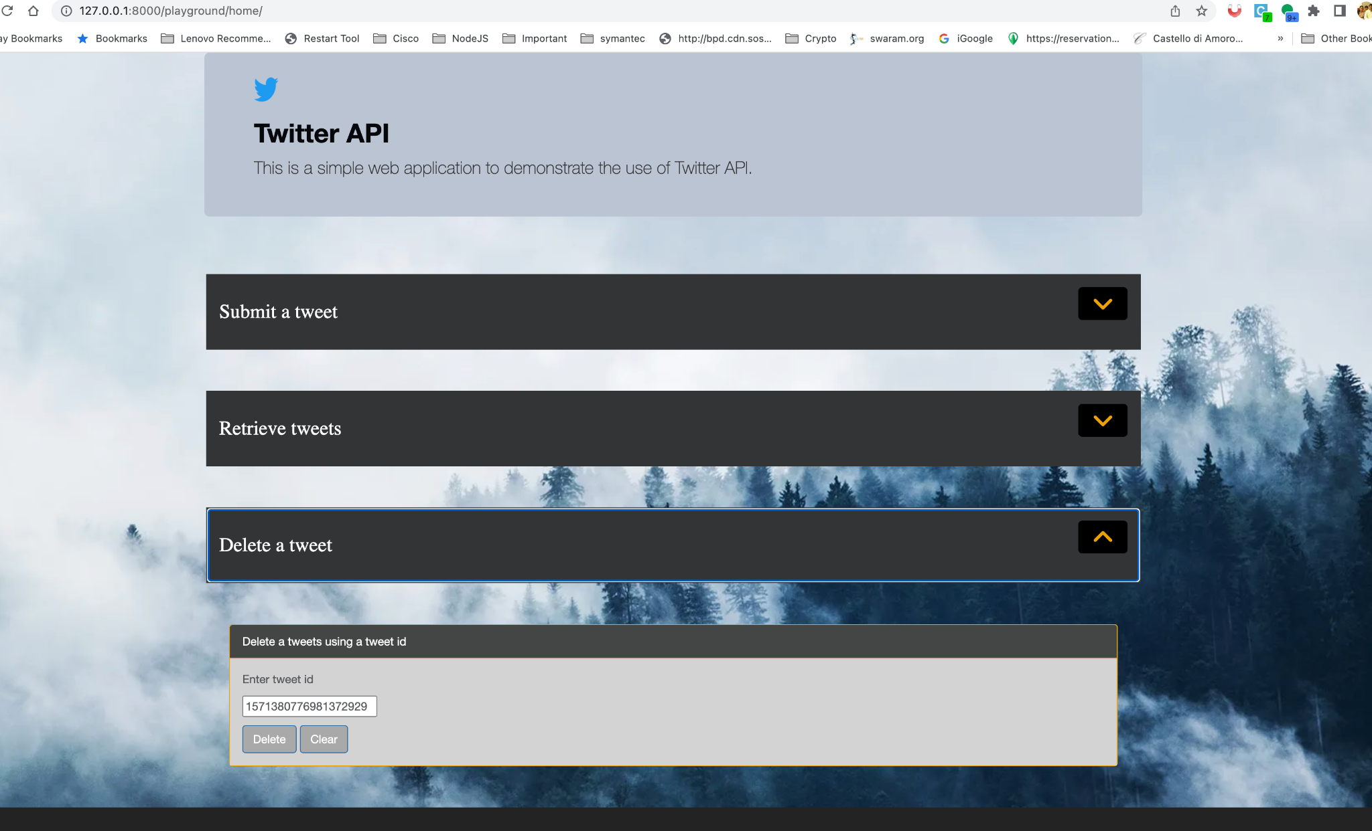

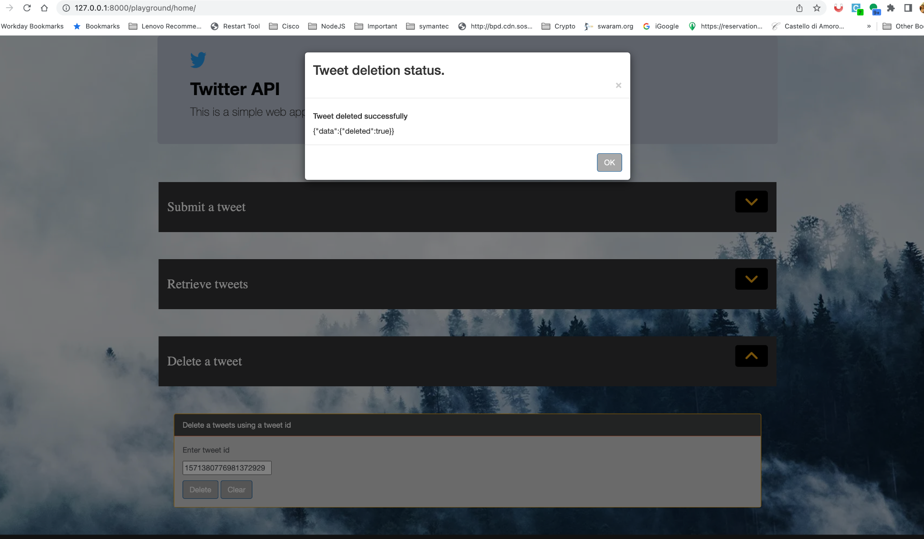

Retrieve Tweets from timeline

You need to provide a user handle (eg: tesla) in the form and click submit . All the tweets from twitter handle are returned and shown in the modal dialog

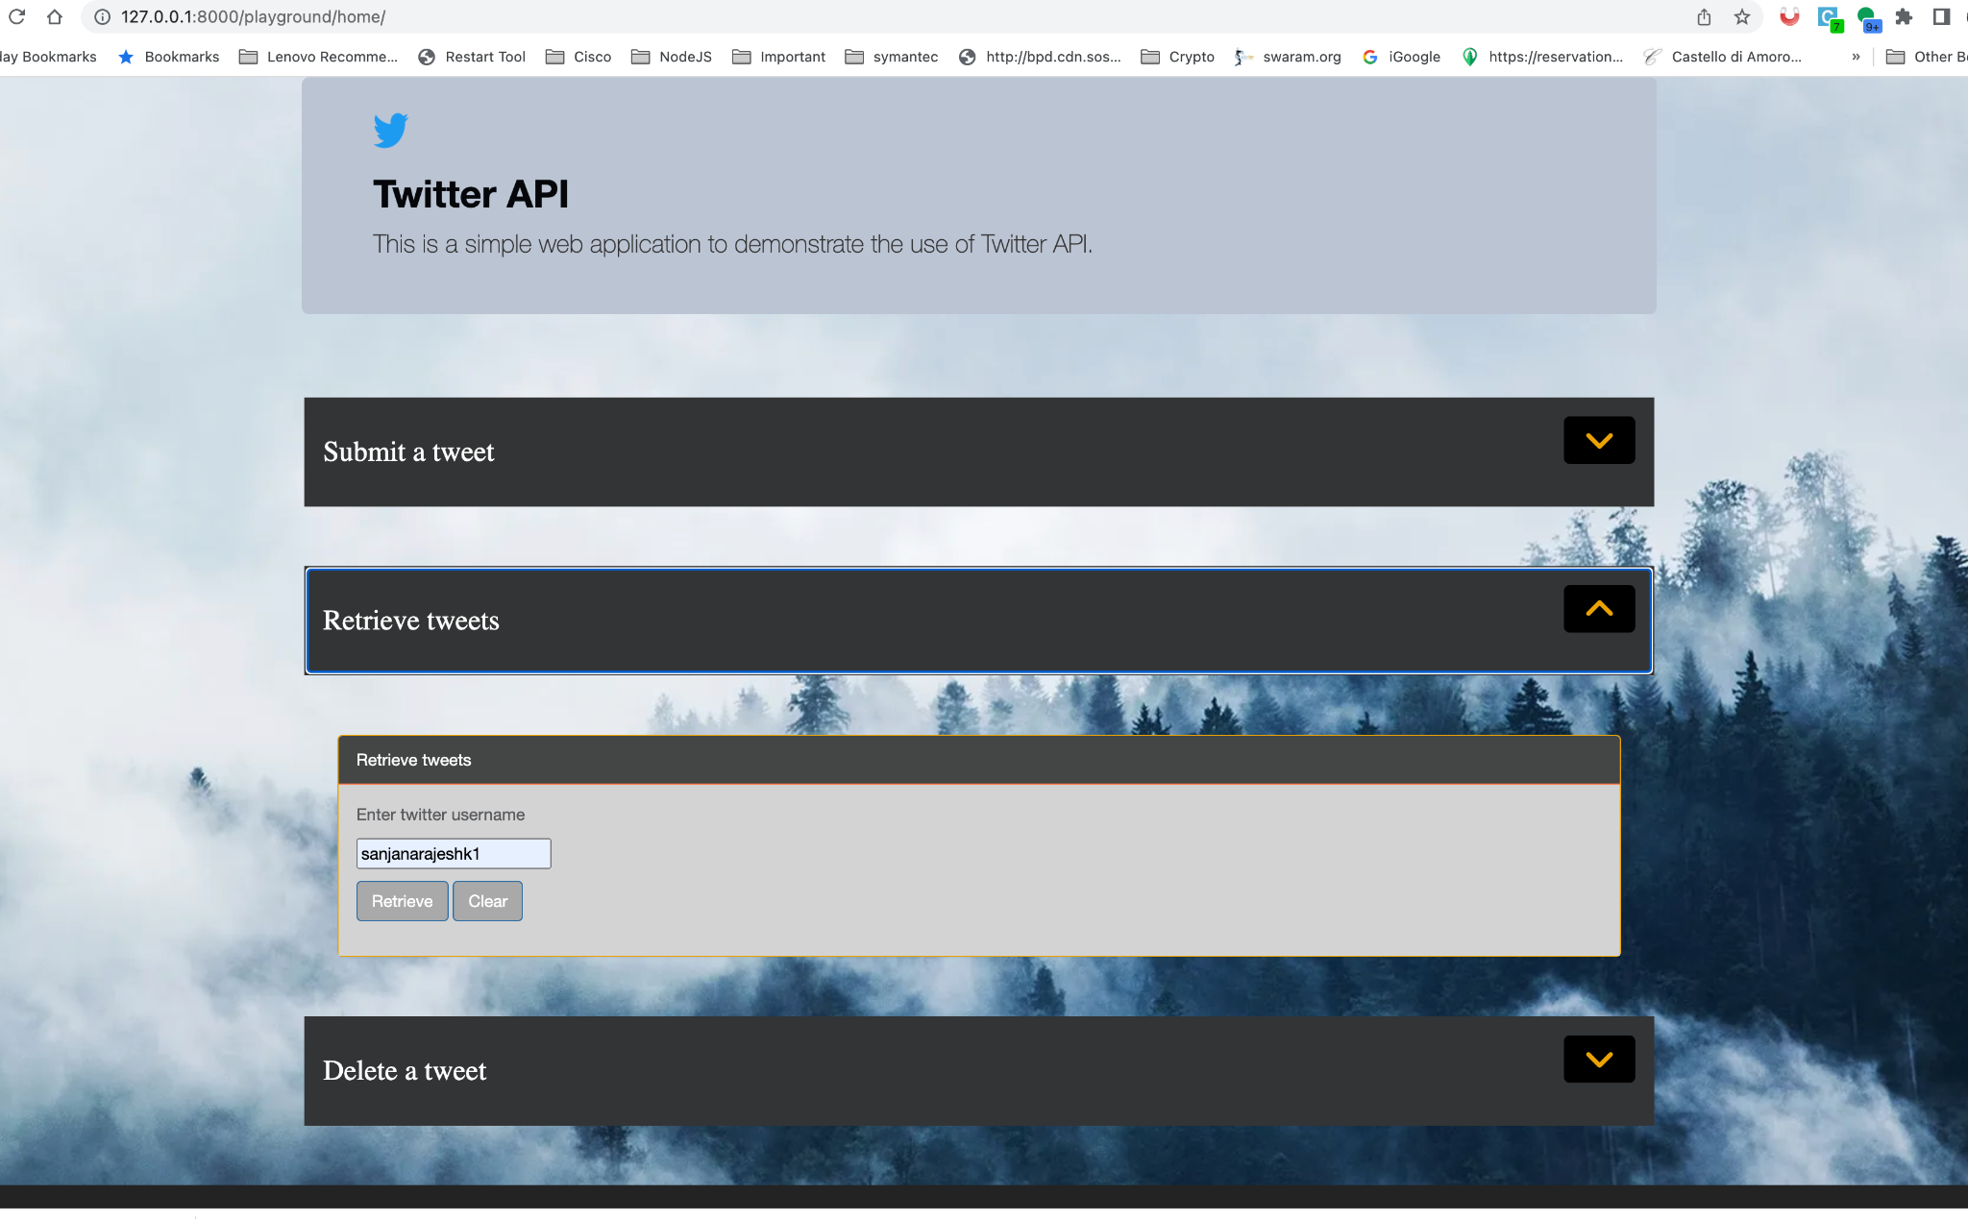

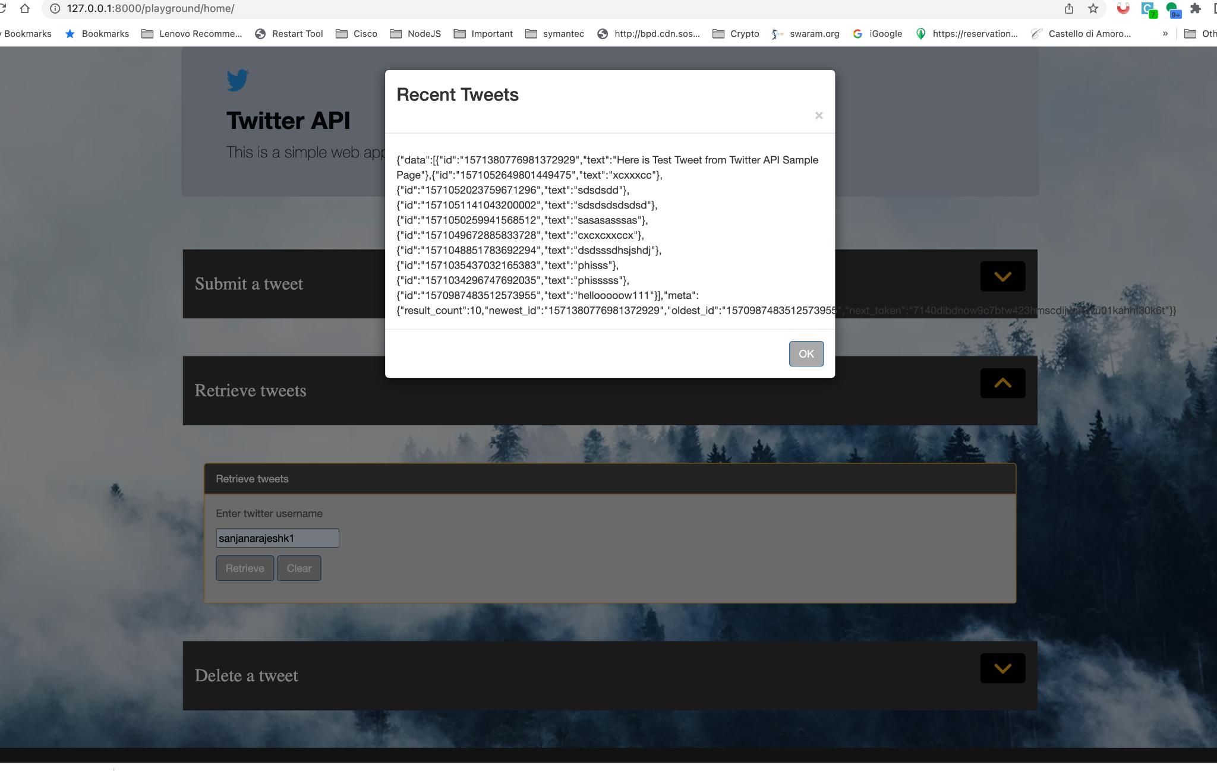

Areas we can improve

a) Sandbox environment setup is not setup as the documentation is very limited

b) Implemented this on Local, Deployment to cloud and make this a public service

c) Better User interface and integrating with twitter widget for results

d) Validations on the page and error handling

Link to Github

<https://github.com/kotharisanjana/Code_Our_Souls>

Code location (with in Zip) :

**HTML :** twitterRestAPI/playground/templates/home.html

**CSS :**

twitterRestAPI/playground/static/css/Portal.css

twitterRestAPI/playground/static/css/main.css

**API :** twitterRestAPI/twitterapi/views.py

**Test cases :** twitterRestAPI/twitterapi/tests.py

Contribution by each team member

[Sanjana Rajesh Kothari](mailto:sanjanarajesh.kothari@sjsu.edu) & [Naga Bathula](mailto:nagasrinivasarao.bathula@sjsu.edu)- Python & Django API development & Code for Twitter API Integration

[Harika Satti](mailto:harika.satti@sjsu.edu)& [Siddhant Sancheti](mailto:siddhant.sancheti@sjsu.edu)- Front end (HTML, CSS and Javascript) for front end

[Ravi Teja Reddy Dodda](mailto:ravitejareddy.dodda@sjsu.edu)- Installation of Django for dev environment & Unit tests